Innovation Capabilities: Affirming an Oxymoron?
Edited by
Tor Helge Aas
Karl Joachim Breunig

Volume X Issue X
2017

----------------------------- page brake ------------------------------

Contents
From the editors
Conceptualizing Innovation Capabilities: A contingency perspective – Aas and Breunig.
Inter- and intra-firm learning synergy through integrating absorptive capacity and employee suggestion processes: The case study of Frauenthal Automotive Toruń company – Lis and Sudolska.
Capable design or designing capabilities? An exploration of service design as an emerging organizational capability in Telenor – Martinkenaite, Breunig and Fjuk.
Dynamic capabilities and innovation capabilities: the case of the ‘Innovation Clinic’ – Strønen, Hoholm, Kværner and Støme.
Dynamic capabilities and network benefits – Svare and Gaudal.
A conceptual framework to represent the theoretical domain of “innovation capability” in organizations – Narcizo, Canen and Tammela.

----------------------------- page brake ------------------------------

From the Editors
The relationship between resources and capabilities and performance has been discussed since Edith Penrose addressed the mechanisms behind the growth of the firm (Penrose, 1959). Early contributions to this area of research suggest that valuable and inimitable resources and capabilities are the primary sources of superior performance and sustained competitive advantage (Barney, 1991; Wernerfelt, 1984), while more recent contributions suggest that the ability to change and re-configure resources and capabilities, (dynamic capabilities) are most important for performance, especially when the market is unstable (Teece, 2014; Teece, Pisano, & Shuen, 1997).
It has also been argued that firms may utilize their resources and capabilities through the development of innovations in the form of new products, services or processes (Hill, Brandeau, Truelove, & Lineback, 2015), and empirical research has confirmed that there is a positive relationship between the implementation of innovation activities and the future performance of firms (Bowen, Rostami, & Steel, 2010; Rubera & Kirca, 2012). However, innovation as a phenomenon entails change as opposed to resources and capabilities that represents a firm’s ability to reproduce a certain performance – and as such involves stability. Viewed in this way the very term innovation capability can constitute an oxymoron.
The study of innovation capabilities is therefore a complex field of study that is emerging. The topic has already attracted interest from a number of scholars (e.g. Forsman, 2011; Guan & Ma, 2003; Hertog, van der Aa, & de Jong, 2010; Wang, Lu, & Chen, 2008; Yam, Lo, Tang, & Lau, 2011), but despite these important advances there is still a lack of consensus in the literature and a pressing need to clarify what type of resources and capabilities drive innovation in different contexts (Lidija & Robert, 2014), and how these capabilities are developed and utilized (Helfat & Peteraf, 2003).
In the assessment of theory informing innovation capabilities we identify how capability dynamics is contingent upon the degree of market changes – static as opposed to fast moving markets. In our assessment of innovation management theory, we identify how organizational innovation processes are contingent upon the degree of novelty - incremental as opposed to radical innovations. Therefore, we suggest analysing what type of innovation capabilities that are required in the four different contexts that emerge by utilizing these two contingency variables to construct a two-by-two matrix.
The first paper by Aas and Breunig introduce the four contexts of innovation capability discussed above and also provide a framework to introduce and position the different contributions in this special issue on Innovation Capability.
In the second paper, Lis and Sudolska address the synergy between inter – and intra firm learning processes in relation to firms’ absorptive capacity in a context where stable markets are observed, but where innovations can be both incremental and radical.
The third paper authored by Martinkenaite, Breunig and Fjuk addresses service design as an emerging organizational capability. The paper illustrates conditions requiring radical innovations in both static and fast moving markets.
In the fourth paper of this issue, Strønen, Hoholm, Kværner and Støme address the innovation capabilities in the healthcare context resembling the traditional dynamic capability perspective where markets can be fast moving and both incremental innovations and radical innovations occur.
The fifth paper of this issue by Svare and Gausdal explores empirically whether variations in firms’ dynamic capabilities can explain variations in the benefits they harvest from participation in regional innovation networks. Like in the fourth paper, this is studied in fast moving markets where both incremental innovations and radical innovations take place.
The sixth and final paper by Narcizo, Canen and Tammela contributes by providing a bibliometical study identifying 19 different definitions of the concept of innovation capability, and subsequently suggesting a conceptual framework based on maturity models distinguishing between three levels of the domain of innovation capability. This framework is applicable to all the four contexts identified here for innovation capability.
How the papers in this issue are positioned in relation to the four contexts is illustrated in Figure 1.
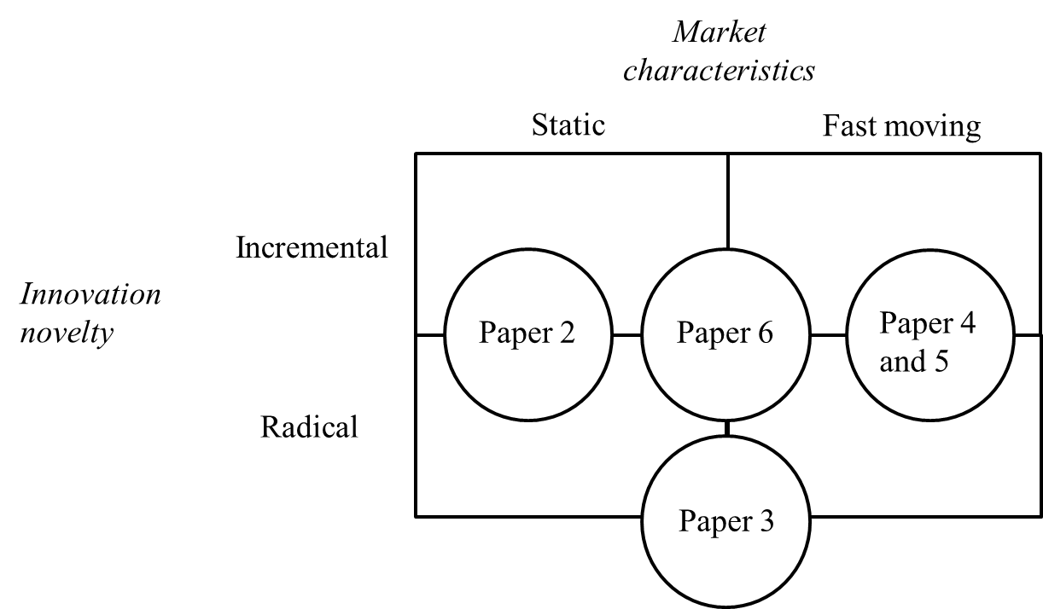
Figure 1: Positioning according to the contingency framework introduced in paper 1 (Aas and Breunig, 2017).

This issue of JEMI combines contributions from Brazil, Poland, and Norway. We would like to express our gratitude to the authors who enabled us to publish this insightful selection of papers for this special issue. We are also very grateful to the anonymous reviewers who have shared their knowledge and experience in a positive and constructive tone - enabling the authors to improve their research. Lastly, we would like to thank Dr. Anna Ujwary-Gil, Editor- in-Chief of JEMI, for the chance to cooperate with JEMI and for her support during each phase of the work on this special issue.
We hope that this issue will prove to be interesting reading for global scholars and inspire them on to further research. Owing to the collaboration between authors, reviewers and editors, the present issue of JEMI offers high-quality contributions to extend our understanding of the concept of innovation capability.

Dr Tor Helge Aas, Associate Professor
School of Business and Law, University of Agder, Norway
Professor Dr Karl Joachim Breunig
Oslo Business School, Oslo and Akershus University College, Norway

References
Aas, T.H., & Breunig, K.J. (2017). Conceptualizing Innovation Capabilities:
A Contingency Perspective. Journal of Entrepreneurship, Management and Innovation, this issue.
Barney, J. B. (1991). Firm resources and sustained competitive advantage. Journal of Management, 17(1), 99-120.
Bowen, F. E., Rostami, M., & Steel, P. (2010). Timing is everything: A meta-analysis of the relationships between organizational performance and innovation. Journal of Business Research, 63(11), 1179-1185.
Forsman, H. (2011). Innovation capacity and innovation development in small enterprises. A comparison between the manufacturing and service sectors. Research Policy, 40(5), 739-750.
Guan, J., & Ma, N. (2003). Innovative capability and export performance of Chinese firms. Technovation, 23(9), 737-747.
Helfat, C. E., & Peteraf, M. A. (2003). The dynamic resource-based view: capability lifecycles. Strategic Management Journal, 24(10), 997-1010. doi:10.1002/smj.332
Hertog, P. d., van der Aa, W., & de Jong, M. W. (2010). Capabilities for managing service innovation: towards a conceptual framework. Journal of Service Management, 21(4), 490-514. doi:10.1108/09564231011066123
Hill, L. A., Brandeau, G., Truelove, E., & Lineback, K. (2015). The Capabilities Your Organization Needs to Sustain Innovation. Harvard Business Review(January 14).
Lidija, B., & Robert, D. H. (2014). Dynamic capabilities vs. innovation capability: are they related? Journal of Small Business and Enterprise Development, 21(3), 368-384. doi:doi:10.1108/JSBED-02-2014-0018
Penrose, E. T. (1959). The Theory of the Growth of the Firm. New York: John Wiley and son.
Rubera, G., & Kirca, A. H. (2012). Firm Innovativeness and Its Performance Outcomes: A Meta-Analytic Review and Theoretical Integration. Journal of Marketing, 76(3), 130-147. doi:doi:10.1509/jm.10.0494
Teece, D. J. (2014). The Foundations of Enterprise Performance: Dynamic and Ordinary Capabilities in an (Economic) Theory of Firms. The Academy of Management Perspectives, 28(4), 328-352. doi:10.5465/amp.2013.0116
Teece, D. J., Pisano, G., & Shuen, A. (1997). Dynamic capabilities and strategic management. Strategic Management Journal, 18(7), 509-534.
Wang, C. H., Lu, I. Y., & Chen, C. B. (2008). Evaluating firm technological innovation capability under uncertainty. Technovation, 28(6), 349-363.
Wernerfelt, B. (1984). Resource-based View of the Firm. Strategic Management Joumal, 5(2), 171-180.
Yam, R. C., Lo, W., Tang, E. P., & Lau, A. K. (2011). Analysis of sources of innovation, technological innovation capabilities, and performance: An empirical study of Hong Kong manufacturing industries. Research Policy, 40(3), 391-402.

